**ABSTRACT**

This project is all about developing a simple Artificial Intelligence game. We have developed a simple AI game named “Space Invader”. This is a simple single player based game. We just need to kill enemies at the top of the surface. If any enemy falls on the player then the game is over.

**INTRODUCTION**

Space Invader is a simple Artificial Intelligence based game which is played by single player. It was released in 1978 in Japan. The developers of this game were Taito and Tomohiro Nishikado and designer was Tomohiro Nishikado. In this game, there is a surface. On the top of the surface, we have n number of enemies. On the bottom of the surface, we have a player who can move horizontally left or right. That player shoots bullet to kill enemies at the top of the surface. As he goes on killing the enemies, the score goes on increasing. But if the enemy falls on the player then game is over.

**LITERATURE REVIEW**

We have used pygame library of Python in this game. So I studied about pygame library from websites like geeksforgeeks etc. Moreover we have read about the different syntax used in game development from those websites, like syntax used for movement of object, drawing object on surface etc. Along with it we have seen a video series for game development on YouTube to understand about game development.

**METHODOLOGY PROPOSED**

This game is developed using pygame library. So first of all we have installed all the packages of pygame. Then we have imported pygame library, then initializesd it to access all features of this library. Using different syntax we have changed the name shown at the top of the surface and changed it to “Space Invader” and to attach background image. We have used different functions for operations to be done on different variables. The movement of the object is done using while loop.

We have also used HTML and CSS to display score and other changing background color of the screen which is later on replaced by a background image.

**RESULT AND DISCUSSION**

When player shoots bullet to kill enemy , his score gets increased by 1. But if any enemy falls on player then he loses and whatever score he has till this point that score is his final score and screen shows “Game Over”

**CONCLUSION**

We have concluded that without using Artificial Intelligence, development of any game is not possible. Moreover Python is the best platform for creating simple Artificial Intelligence based games. Development of game shows how Artificial Intelligence is used in gaming industries and it is proving beneficial for development of gaming industry.

**PLAGIARISM**

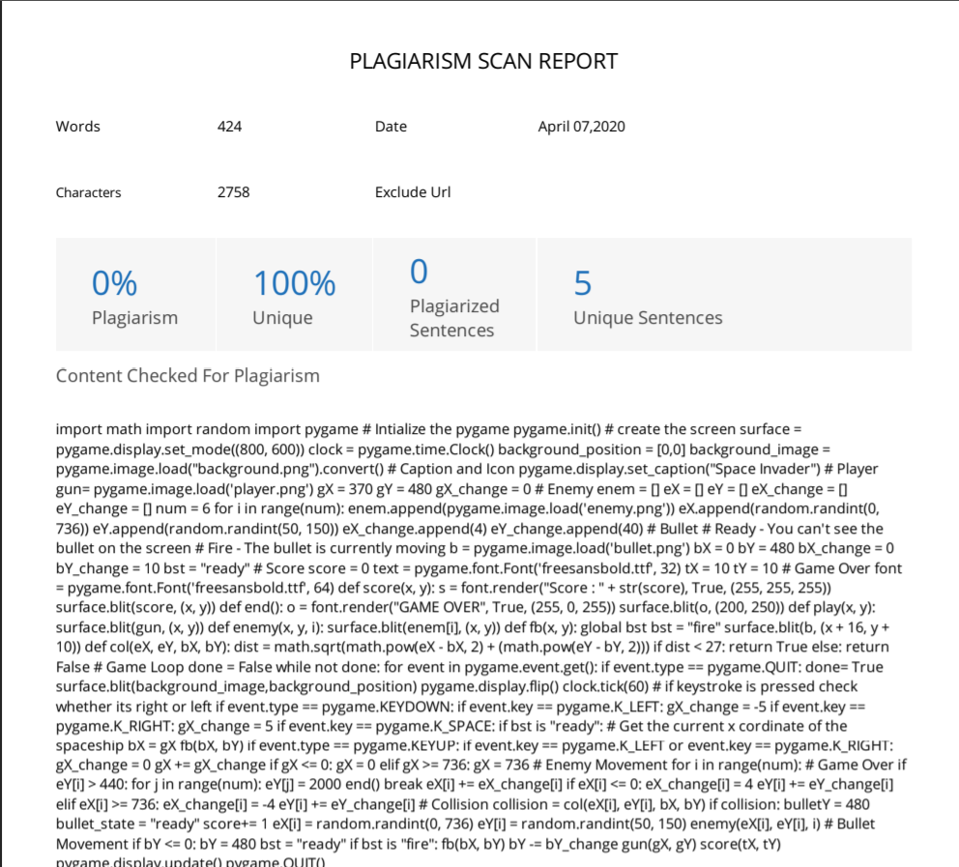

**CONTRIBUTION BY GROUPMATES :**

This project is combined effort of all of us. Different contributions given in fields by different groupmates are :

Subrat Shukla (Reg. no- 11811007 , Roll no. – 41) : Written code for movement mechanics of player along with code for changing background image. Also made the report.

Sucharita Biswas (Reg. no- 11811261 , Roll no. – 44) : Written code for movement mechanics of bullet along with code for handling the game screen.

Abdul Rahman Khan (Reg. no- 11811259, Roll no. – 43) : Written code for movement mechanics of enemies along with code for changing background colour of the screen at the starting.

Raj Kiran Tiwari (Reg. no – 11811248 , Roll no. – 42) : Written code for mechanics of collision and code for displaying score.